TO, Review Manuscript for Journal of Advances in Biology & Biotechnology

Firstly, I thank you to you and your team to consider me in the part of Review Manuscript for Asian Journal of Microbiology and Biotechnology.

I write my suggestion in below

This paper written by you is well written, it had knowledge things in it. I hope it is a grateful help to the nation, but there is a lack of reference, Could you provide an appropriate response with a reference ?

Dimri et al., (2000) in Haematological values part you mention this reference but no present in reference.

(Mueller et al., 2011) & (Mueller, 2008) in introduction part you mention this reference but no present in reference (Mueller, 2008).

Pradhan (2015) & Pradhan (2012) in Haematological values part you mention this reference but no present in reference while only present Pradhan (2012).
- You mention in reference list, but not present in your paper Scott, D. W., Miller, W. H. and Griffin, C. E. (2001a). Muller and Kirk‟s small animal dermatology 6th edition. Philadelphia: WB Saunders, 543-666.

Original Research Article

An Update on Pathological changes in Canine Demodicosis

ABSTRACT
A total of 240 dermatitis cases studied in dogs at Veterinary Clinical Complex, College of Veterinary and Animal Science, Bikaner, Rajasthan, from the period of September 2018 to February 2019. Out of these, 25 dogs were positive for demodicosis was diagnosed by examination of deep skin scrapings. In this study, 19 were affected with generalised demodicosis and 6 were affected with localized demodicosis. In deep skin scrapings, demodectic mites were detected.
Haematological studies in canine demodicosis cases revealed anemia, leucocytosis, neutrophilia, lymphopenia and eosinophilia. Serum biochemistry in canine demodicosis cases revealed hypoglycemia, hypoproteinemia, hypoalbuminemia, hyperglobulinemia, increased level of SGPT and SGOT. Mineral study in the canine demodicosis revealed decreased level of serum zinc, copper and iron.
Histopathological changes in canine demodicosis showed desquamation and degeneration of external root sheath cells with pigment deposition, necrotic hair follicle markedly distended and filled with keratin, debris and purulent material. In present study histopathology revealed cross section of the mite in the epidermis with hyperpigmentation.
Keywords: Demodicosis, Hematology, Biochemistry, Histopathological changes.

INTRODUCTION
Demodectic mange is a severe parasitic skin disease of dog caused by an overpopulation of the follicular mite of various Demodex species. Demodex canis (Figure 1) is the main causative agent of canine demodicosis (Scott et al. 2001). The mites spend their entire life cycle on the skin of host. The life cycle of Demodex is that an egg (fusiform shaped) develops into 6 legged larvae that then develops into an 8 legged nymph (Mueller, 2008).
It is assumed that immunosuppression or a defect in the skin immune system allows mites to proliferate in hair follicles (Mueller et al., 2011).
Demodex mites multiply in hair follicles and sebaceous glands causing severe inflammation. To study the severity of damage caused, histopahological study of skin section was carried out. The aim of the article presented here was to describe the pathological findings in demodectic dogs.

MATERIALS AND METHODS
Animals presented to Veterinary Clinical Complex (VCC), College of Veterinary and Animal Science, Bikaner with dermatological signs were taken for present study. All the cases screened for dermatological disorders were clinically examined followed by routine haematological, serum biochemistry, mineral estimation, skin scrapping was done.

Hematology and Serum Biochemistry analysis
About 5 ml of blood was collected aseptically from cephalic vein of the affected dogs and the serum was separated out. Blood was collected in sterile tubes coated with anticoagulant disodium salt of ethylene diamine tetra acetic acid (EDTA). Similarly blood and serum was collected from apparently healthy dogs for conducting haemato-biochemical studies. The serum was pipetted out in small tubes and was kept immediately in the deep freeze at -20ºC till analyses.

Hematology
The blood samples were subjected for estimation of hemoglobin, packed cell volume, total erythrocyte count, total leukocyte count and differential leukocyte count. These parameters were analyzed as per the methods described by Jain (1986).

Biochemical estimations
Biochemical analysis of serum samples were carried out to estimate serum glucose, serum total protein, albumin, globulin, A/G ratio, SGPT, SGOT, BUN and serum creatinine.
Above biochemical estimations were evaluated with autoanalyser (IDEXX VetAutoread IDEXX Lab.) using standard kits.

Serum mineral estimation
Serum sample were digested as per the procedure described by Kolmer et al. (1951). Serum 1 ml with of Double Acid mixture (conc.HNo3 + 70% perchloric acid in 2: 1 ratio) 1 ml was mixed in digestion tube and digested on low heat (70-80ºc) using heat bench until the digested sample become watery clear and emitted white fumes and volume reduced to 0.5 ml. Final volume of filtrate was made up to 25 ml with triple distilled, deionised water. Then the Zinc, cobalt and copper was estimated from digested serum sample using iCAP 7000 Series Spectrometer.

Histopathology
For histopathological studies, skin biopsies were collected from affected dog with canine demodicosis. The affected area was gently cleaned with 70% alcohol and the site was desensitized with local anaesthetic solution (Lignocaine hydrochloride, 1-2%) subcutaneously (Wilkinson and Harvey, 1994). Punch biopsy instrument (4 mm diameter) was placed on the area of skin to be biopsied and the punch was drilled into the tissue with rotary motion in one direction applying moderate pressure (Muller and Kirk, 1969; Nesbitt, 1983). The punch was withdrawn and the circular piece of skin was snipped off from the punch by a sterile scalped while holding the piece of skin with a plain forceps. The wound was closed with one skin stitch. The biopsy of the skin thus obtained was preserved in 10% formalin. The biopsy samples were processed for paraffin sectioning method as described by Luna (1968). The paraffin sections of 6-8µ thickness were cut and stained by routine Mayer’s Haematoxylin and Eosin staining method and Periodic Acid Schiff (PAS) stain (Drury and Wallington, 1980).

Statistical analysis
The data obtained was compiled and statistical analysis will be carried out as described by Snedecor and Cochran (1968).

RESULTS AND DISCUSSION
In the present study hematological, Biochemical and mineral examination was done in 25 dogs positive for canine demodicosis which was compared with values of apparently healthy animals.

Haematological values
Haematological values in apparently healthy dogs and demodectic dogs are presented in Table 1.
The mean±S.E haemoglobin (gm/dl) value in canine demodicosis dogs was significantly lower compared to healthy animals. Similarly low haemoglobin content was reported by Pradhan et al. (2012), Chakraborty and Pradhan (2015) and Kumar et al. (2018). This condition might be due to reduced appetite, loss of blood during scratching and also loss of skin protein as mentioned by Chakraborty and Pradhan (2015) or due to the stress arising from the disease (Sakina et al., 2012).
In the present study mean±S.E PCV% of demodectic dogs was significantly lower than healthy group showing PCV%, which could be due to aneamia. This finding is in accordance with Nair and Nauriyal (2007), Srikala et al. (2010), Janus et al. (2014) and Haleem et al. (2015).
The haematological studies revealed a significantly (P<0.05) lower TEC in dogs with canine demodicosis. These findings were in agreement with the Singh et al. (2011), Oludunsin et al. (2014), Chakraborty and Pradhan (2015) and Haleem et al. (2015). The decrease in TEC could be related to the deteriorated condition of the dogs due to continuous itching and reduced appetite.

Total leukocyte count was significantly (p<0.05) higher in dogs with canine demodicosis. According to Dimri et al., 2006 the allergic reaction due to mites or their products coupled with the inflammatory process might have contributed to leukocytosis.
Neutrophilia condition accordance with Reddy et al. (2014a), Chakraborty and Pradhan (2015) and Kumar et al. (2018), who reported that generalized inflammation and response of leukocytes to prolonged antigenic stimulus might have resulted in leukocytosis and neutrophilia.
Lymphopenia condition accordance with Chakraborty and Pradhan (2015), Haleem et al. (2015) and Kumar et al. (2018). Lymphopenia might be due to the reason that cell mediated immunity plays important role in fighting against demodectic mites.
Increased eosinophil count was also reported and similar observation also reported by Reddy et al. (2014a), Chakraborty and Pradhan (2015) and Kumar et al. (2018). Dimri et al., (2000) opined that D. canis causes irritation of the skin tissues and stimulates the mast cells for release of more histamine and since histamine is chemotactic for eosinophils from the bone marrow to the circulation leading to eosinophilia.
In the present investigation, there was a significant decrease in monocyte value of demodectic dog as compare with healthy group while no significant changes in besophils.

Table1 Mean±S.E haematological values of healthy control and canine demodicosis dogs
Parameters | Healthy dog (n=6) | Positive dog (n=25)
Hb (g/dl) | 13.93±0.22 | 9.82±018*
PCV (%) | 40.67±1.2 | 26.52±0.48*
TEC (10⁶/μl) | 6.4±0.2 | 5.0±0.08*
TLC (10³/μl) | 11.3±0.82 | 15.570.29*
N (%) | 71±2.29 | 83.52±0.48*
L (%) | 21.83±2.34 | 9.24±0.28*

M (%) | 5.83±0.87 | 2.16±0.23*
E (%) | 1.17±0.31 | 4.88±0.37*
B (%) | 0.17±0.17 | 0.2±0.08
*Significant (p < 0.05)

Biochemical values
The mean serum biochemistry values of healthy control dogs and the dogs with demodicosis are given in table 2.
In the present investigation, the mean±SE total serum protein and albumin in dogs with canine demodicosis was significantly (p>0.05) lower when compared to healthy control dog. But the mean globulin was significantly higher in dogs with demodicosis when compared to apparently healthy dog. Significant hypoprotenemia, hypoalbuminaemia and hyperglobulinaemia was found similar findings was also noted by previous workers Dadhich and Khanna (2008), Sakina et al. (2012) and Pradhan et al. (2012). Decreased levels of serum albumin in the present study might be the result of excessive breakdown of proteins due to trauma to skin and proliferation of mites. Elevated globulin level might be indicator of immune response following severe mite infestation in canine demodicosis (Sakina et al., 2012 and Haleem et al., 2015)
There was no statistically significant (p>0.05) difference found in the BUN and creatinine which was in similar to the findings of Haleem et al. (2015).
In the present study blood glucose level in demodectic dog was significantly lower as compare to healthy control dog. Blood glucose was similar to previous finding by Kumar et al. (2018). Hypoglycaemia might be due to increased need of glucose during inflammatory reactions as suggested by Gupta (2008) and Kumar et al. (2018).
The mean±SE values of ALT (U/L) and AST (U/L) values of demodectic dog were significantly higher as compare with healthy control dog. This was in agreement with Arora et al. (2013), Haleem et al. (2015) and Kumar et al. (2018). The elevation of these parameters could be due to the hepatic damage caused by toxic products from mites (Kaneko et al., 1997).

Table 2 Mean±S.E serum biochemical values of healthy and canine demodicosis positive dogs
Parameters | Healthy (n=6) | Positive dog (n=25)
Total protein (g/dl) | 6.63±0.16 | 6.03±0.1*
Albumin (g/dl) | 3.17±0.13 | 2.02±0.0+06*
Globulin (g/dl) | 3.47±0.09 | 4.01±0.07*
A:G ratio | 0.91±0.04 | 0.51±0.02*
Glucose (mg/dl) | 98.33±2.03 | 83.2±0.93*
ALT/SGPT U/L | 20.67±0.49 | 26.72±0.51*
AST/SGOT U/L | 23.5±0.43 | 29.64±0.40*
BUN (mg/dl) | 12.5±0.56 | 13.84±0.29
Creatinine (mg/dl) | 0.85±0.08 | 1.19±0.04
*Significant (p < 0.05)

Mineral Estimation
In the present investigation the mean±SE values of serum zinc, copper and iron concentration significantly low in canine demodicosis affected dog (Table3). The levels of serum zinc and copper concentrations are in agreement with Dimri et al. (2008) who reported that blood zinc and copper levels in dogs with canine demodicosis were significantly (P < 0.01) lower than healthy control and similarly Beigh et al. (2013) observed that in comparison to healthy control, zinc and copper levels were significantly (P < 0.01) lower in dogs with generalized demodecosis.
Arora et al. (2013) and Jyotsna et al. (2005) reported decreased serum iron levels in canine demodicosis affected dogs. According to Klassing, 1998 during inflammation interleukins are released from activated phagocytes that lower zinc concentration, resulting from increased synthesis of metallothionein in liver. Metallothionein binds 7g atoms of Zn/mol and is an efficient mechanism for removing zinc from circulation. As reported by Nath et al. (1984) the observed lower concentration of copper and zinc could be attributed to their over utilization in the synthesis of antioxidant enzymes to counter oxidative stress .

Table 3 Mean±S.E values of serum Zn, Cu and Fe value in healthy and canine demodicosis positive dogs

Parameters | Healthy (n=6) | Positive dogs (n=25)
Zn (µg/ml) | 1.42±0.09 | 0.71±0.02*
Cu (µg/ml) | 1.13±0.1 | 0.496±0.02*
Fe (µg/ml) | 1.26±0.22 | 0.28±0.01*
*Significant (p < 0.05)

Histopathlogical changes
The histopathology of skin biopsy sections from positive cases of canine demodicosis revealed that there was excessive degeneration of the hair follicles in the affected dogs. The degenerative changes included desquamation of the papillary cells, detachment of the hair shaft and its extrusion from the follicle, loss of the hair cuticle as well as the inner root sheath, degeneration of the glossy membrane of the hair follicle, desquamation and degeneration of external root sheath cells with pigment deposition. A large number of dark pigmented granules of variable sizes were found accumulated at the periphery of the parasitized hair follicles suggesting hyperpigmentation. (Figure 1)
The hair follicles were necrotic, markedly distended and filled with keratin, debris, purulent material and numerous Demodex mites cut in different planes inside hairfollicles. (Figure 2 and 3)
The hyperpigmentation was due to increased melanocytic activity in the epidermis suggested by Solanki et al. (2011).
Similar results of histopathology changes in canine demodicosis was found by Ballari et al. (2009) which included dilated hair follicles with cross sections of demodex mites, hyperkeratosis, melanin pigment accumulation, furnculosis and extrafollicular inflammatory changes.

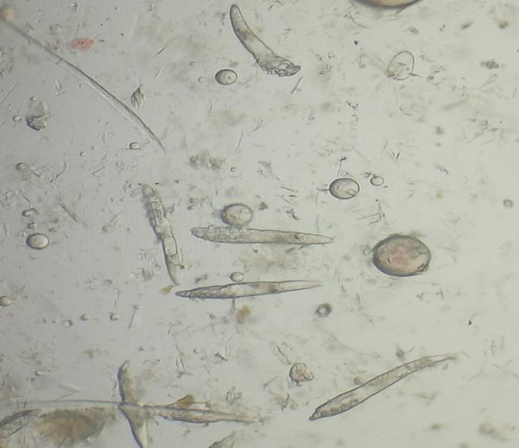 | 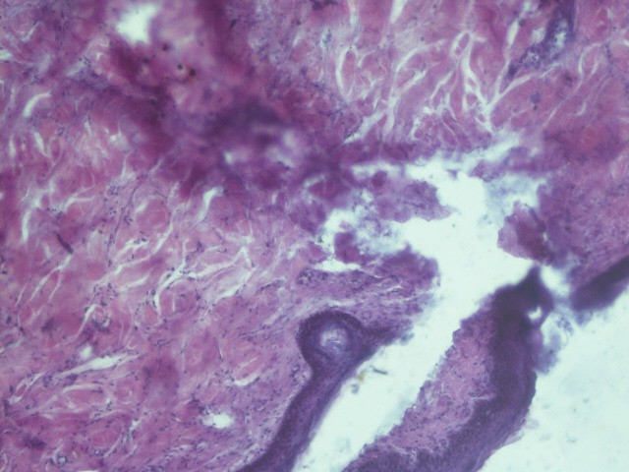
Figure 1 Demodex mite | Figure 2 Desquamation and degeneration of external root sheath cells with pigment  deposition.100x
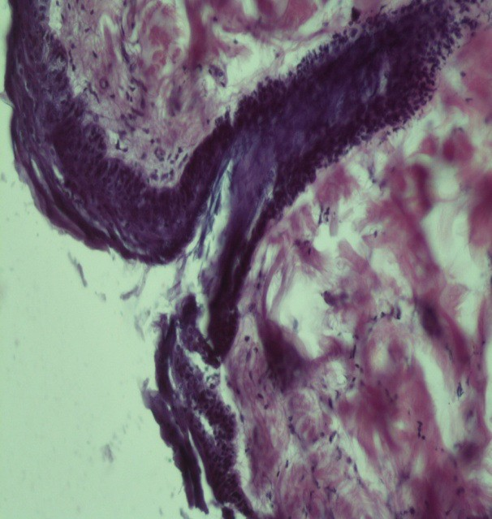 | 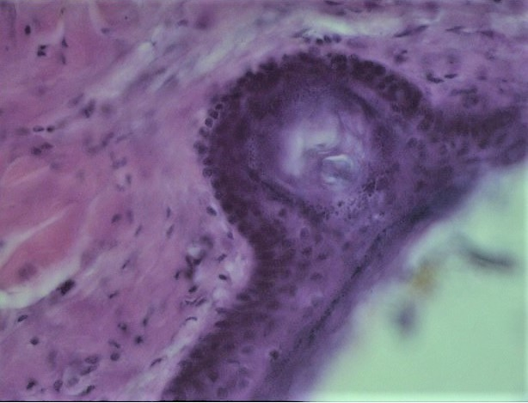
Figure 3 The hair follicle was necrotic, markedly distended and filled with keratin, debris, purulent material in hair follicles.200x | Figure 4 Cross section of mite in epidermis, dark pigmented granules as hyperpigmentation 400x

CONCLUSION
In conclusion Haematological study revealed anaemia, leucocytosis with neutrophilia, eosinophilia and lymphopenia in canine demodicosis affected dogs.
Biochemical study revealed hypoprotenemia with hypoalbuminemia, hyperglobulinemia, low serum iron, zinc and copper levels.

In conclusion of histopathology revealed cross section of the mite in the epidermis with hyperpigmentation.

REFERENCES
Arora, N., Vohra, S., Singh, S., Potliya, S., Lather, A., Gupta, A., Arora, D. and Singh, D. (2013). Therapeutic management of chronic generalized demodicosis in a pug. Advances in Animal and Veterinary sciences, 1(2): 26-28.
Ballari, S., Balachandran, C., George, V. T. and Manohar, B. M. (2009). Pathology of canine demodicosis. Journal of Veterinary Parasitology, 23(2): 179-182
Beigh, S. A., Soodan, J. S., Singh, R., and Khan, A. M. (2013). Trace minerals status and antioxidative enzyme activity in dogs with generalized demodecosis. Veterinary parasitology, 198(1-2): 180-186.
Chakraborty, S. and Pradhan, N. R. (2015). Canine demodicosis and its herbal and nonherbal treatments. Indian Journal of Canine Practice, 7(2): 115.
Dadhich, H. and Khanna, R. (2008). Pathological, haemato-biochemical and immunological studies of cutaneous ectoparasitoses in dogs. Measurement, 40: 58-65.
Dimri, U., Ranjan, R., Kumar, N., Sharma, M. C., Swarup, D., Sharma, B. and Kataria,
M. (2008). Changes in oxidative stress indices, zinc and copper concentrations in blood in canine demodicosis. Veterinary parasitology, 154(1-2), 98-102.
Dimri, U., Sharma, M. C., Dwivedi, P. and Sharma, B. (2006). Clinico-pathological changes in canine demodicosis with particular reference to Dectomax therapy. Indian Journal of Veterinary Pathology, 30(1): 13-15.
Drury, P. A. B. and Wallington, E. A. (1980). Carleton’s histological technique. (5th edn.) Oxford university press, Oxford, p. 237.
Gupta, A. (2008). INVESTIGATION ON DIETARY AND ENVIRONMENTAL
COMPONENTS VIS-À-VIS SKIN HEALTH IN DOGS (Doctoral dissertation, CSKHPKV, Palampur).

Haleem, M. M. A., Salib, F. A. and Farag, H. S. (2015). Evaluation of Haematological Parameters, Biochemical Parameters and Thyroxin Level in Dogs with Generalized Demodicosis. Global Veterinarian, 15(1): 133-136.
Janus, A., Tresamol, P. V., Mercey, K. A., Habeeb, B. P. and Shameem, H. (2014). A study on clinical and haematobiochemical parameters in canine demodicosis. Indian Journal of Canine Practice, 6: 92-94.
Jyotsna, P., Maiti, S. K., Sanyal, P. K. and Tiwari, S. P. (2005). Haematobiochemical and mineral profiles in generalised canine demodicosis. Intas Polivet, 6(2): 331-334.
Kaneko, J. J., Harvey, J. W. and Bruss, M. L. (1997). Clinical Biochemistry of Domestic Animals. 5th Edition, Academic Press, London.
Klassing, G. C. (1998). Nutritional aspects of leukocytic cytokines. Journal Nutrition,
118: 1435–1443.
Kolmer, J. A., Spandling, E. H. and Robinson, H. W. (1951). Applied laboratory technique 5th Edn, Appleton century craft Inc., New York, USA
Kumar, A., Das, A. K., Sinha, M., Arya, S. K. D., Kumar, A., and Kumar, B. (2018). Study on the Prevalence of Demodectic Mange in Dogs in and Around Patna. International Journal of Current Microbiology and Applied Sciences, 7: 4216-4221.
Luna, L. G. (1968). Manual of histologic staining methods of Armed Forces Institute of Pathology. (3rd edn.) McGraw hill book company, New York, p 258.
Mueller, R. S. (2008). Demodicosis a frequent problem in the dog. Proceedings of the 33rd World Small Animal Veterinary Congress Dublin, Ireland.
Muller, G. H. and Kirk, R. W. (1969). Small animal dermatology. II. W. B. Saunders Co., Philadelphia, P. A.
Nair, S. S. and Nauriyal, D. S. (2007). Diagnostic significance of Haematological changes associated with various Canine Dermatoses. Intas polivet, 8(1): 68-72

Nath, N., Chari, S. N., Rath, A. B. (1984). Superoxide dismutase in diabetic polymorpho nuclear leukocytes. Diabetes 33: 586–589.
Nesbitt, G. H. (1983). Canine and feline dermatology: A systematic approach. Lea and Febiger, Philadelphia.
Oludunsin, F. O., Emmanuel, O., Olayide, A. J., Augustine, O. O., Jokotola, A. O., Tolulope, O. S. and Simon, S. (2014). Death of a four-year-old German shepherd dog due to Demodex canis in Ibadan, Southwest Nigeria: a case report. Research, 1: 887.
Pradhan, N. R., Chatterjee, S. and Lodh, C (2012). Demodicosis in dogs and its therapeutic management. Indian Journal of Canine Practice, 4(1): 44-48.
Reddy, B. S., Kumari, K. N., Sivajothi, S. and Venkatasivakumar, R. (2014a). Dermatitis due to Mixed Demodex and Sarcoptes Mites in Dogs. Case Reports Veterinary Medicine Volume, 2014.
Sakina, A., Mandial, R. K., and Mudasir, Q. (2012). Haematobiochemical changes in canine demodecosis. Vet Scan, 7: 75-78.
Scott, D. W., Miller, W. H. and Griffin, C. E. (2001a). Muller and Kirk‟s small animal dermatology 6th edition. Philadelphia: WB Saunders, 543-666.
Singh, S. K., Dimri, U., Sharma, M. C., Swarup, D., Sharma, B., Pandey, H. O. and Kumari, P. (2011). The role of apoptosis in immunosuppression of dogs with demodicosis. Veterinary Immunology and Immunopathology, 144; 487– 492.
Snedecor, G. W. and Cochran, W. G. (1968). Statistical methods, 6th Ed. Oxford and IBH Publishing Co., New Delhi.
Solanki, J. B., Hasnani, J. J., Panchal, K. M., Naurial, D. S., and Patel, P. V. (2011). Histopathological changes in canine demodicosis. Haryana Veterinarian, 50: 57-60.
Srikala, D., Satish, K. K., Amruth, K. V. V. V., Nagaraj, P., Ayodhya, S. and Rao, T. (2010). Management of mixed infestation of Malasseziosis and Demodicosis in Dogs. Intas Polivet, 11 (1): 74-76.

Wilkinson, G. T., and Harvey, R. G. (1994). Color atlas of small animal dermatology- A guide to diagnosis (2nd edn.). Mosby-Wolfe Publishers.

